TITLE OF THE PAPER TITLE OF THE PAPER TITLE OF THE PAPER TITLE OF THE PAPER
BY
*FIRST AUTHOR’S NAME, **SECOND AUTHOR’S NAME….. and ***LAST AUTHOR’S NAME
Abstract. Abstract, abstract, abstract, abstract, abstract, abstract, abstract, abstract, abstract, abstract, abstract, abstract, abstract, abstract, abstract, abstract, abstract, abstract, abstract, abstract, abstract, abstract, abstract, abstract, abstract, abstract, abstract, abstract, abstract, abstract, abstract, abstract, abstract, abstract, abstract, abstract, abstract, abstract. Abstract, abstract, abstract, abstract, abstract, abstract, abstract, abstract, abstract, abstract, abstract, abstract, abstract, abstract, abstract, abstract, abstract, abstract, abstract, abstract, abstract, abstract, abstract, abstract, abstract, abstract, abstract, abstract, abstract, abstract, abstract, abstract, abstract, abstract, abstract, abstract, abstract, abstract, abstract, abstract, abstract, abstract, abstract, abstract, abstract, abstract, abstract.
Keywords: five key words.
1. Introduction
The text of paper uses Times New Roman, 11pt, Normal, Indentation First Line 1cm. The references should be given in square brackets, for example [1].
2. The next section (first order headings)
The figures are included in the text (Spacing Before 1 li=10pt). Usually, the figures are centered and followed by their captions.
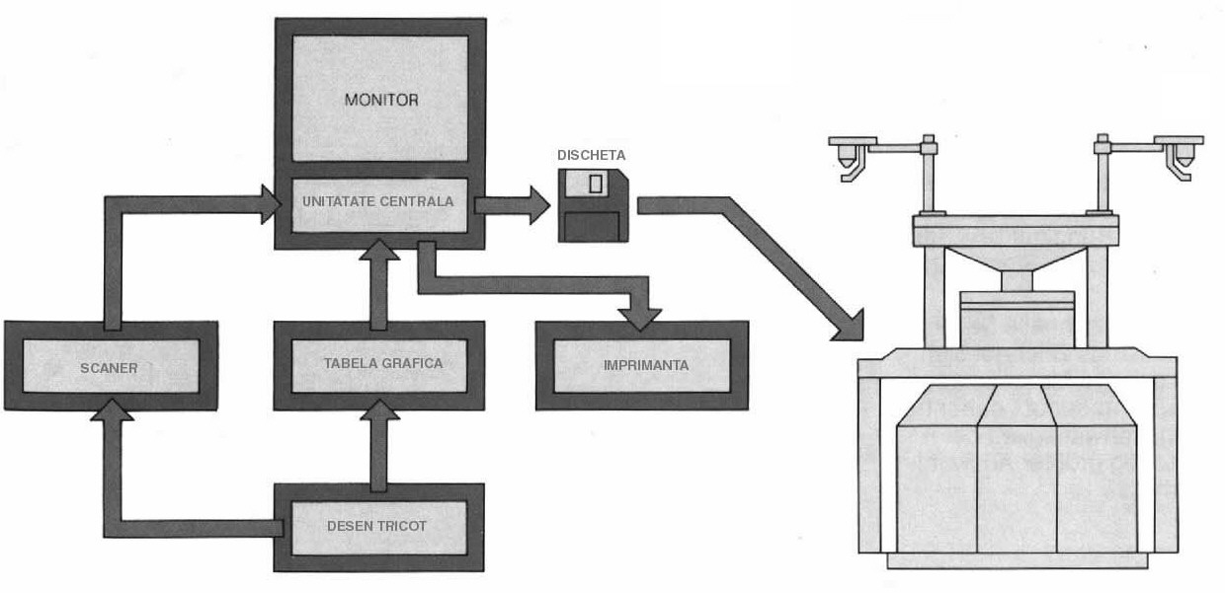
Fig. 1.- Figure’s caption.
The equations should be centered and their numbers are aligned to the right margin. The size of equations is 11pt. The equations’ style is defined with Italic for variables, functions and vectors. The following notations are accepted: limit (lim), exp (e), derivative (d).
$F_{i}=M_{e}a_{v}=−M_{e}ω^{2}⋅y$ (1)
The tables are included in the text, in the order of reference, centered and accompanied by the number and the title positioned at the top of the table. The size of text tables is Times New Roman, 9 pt, Normal.
Table 1
The recommended fonts.
Type size | Normal | Bold | Italic
8pt | Headers (upper case)
9pt | English abstract, Figure captions, Text tables | Second order headings, Appendix  Number table | Romanian abstract, Table captions, Authors’ affiliations, Titles of Citated references
10pt | Authors’ names
11pt | Main text | First order headings | Equations (variables, functions, vectors)
12pt | Title paper (upper case)
2.1 The second order headings
The second order headings is centered and should be in bold capital and small letters. It should be preceeded by one line and followed by one line of space.
The other seminars try to equip students with methods and techniques of intellectual activity that are meant to develop their study skills and their autonomy as learners and also to familiarize them with the standards of academic writing specific for the technical and scientific fields. Some of the issues discussed during the seminars are: learning styles and strategies, academic study skills, library research strategies, using sources, research methods and strategies.

Received at 15th of July 2007

*Author’s affiliation (institution, city, country);
** Author’s affiliation (institution, city, country).

R E F E R E N C E S [follow the examples written below]
- Smith J., Titles of Citated reference. Publishing house, City, year.
- Smith J., Titles of Citated reference. Journal name, 223-231, 2005.
- ……
TITLE OF THE PAPER [IN ROMANIAN LANGUAGE]
(Rezumat)
Romanian abstract. Romanian abstract. Romanian abstract. Romanian abstract. Romanian abstract. Romanian abstract. Romanian abstract. Romanian abstract. Romanian abstract. Romanian abstract. Romanian abstract. Romanian abstract. Romanian abstract. Romanian abstract. Romanian abstract. Romanian abstract.

IMPORTANT

The papers will be sent in WORD format as attached document, named as “CORTEP_full text_author surname” via e-mail:
cortep07@tex.tuiasi.ro
cortep_org@tex.tuiasi.ro

E-mail Subject : CORTEP 2007

